

TOLLFREE +1-800-626-1035

(7 Days a Week: 9:00 AM - 1:00 AM EST)

Monday to Sunday, May 21, 2020

***Patient Order Form***

Email Completely filled scanned copy of the ORDER FORM at [**info@emedsmart.com**](mailto:orders@completemedonline.com)

# Personal Information

Patients First Name: Patients Last Name: Gender:

# Address Information

Street Address:

City:

Zip Postal Code:

Patients State / Province:

Country:

# Contact Information

Phone No.: Best Time to be contacted:

Fax number:

# Medical Information

|  |  |  |  |  |
| --- | --- | --- | --- | --- |
| **S.No.** | **Medication Name** | **Strength** | **Quantity** | **Price** |
|  |  |  |  |  |
|  |  |  |  |  |
|  |  |  |  |  |
|  |  |  |  |  |

**Payment Options-**

1. **Pay Via PayPal**

Customer Support team will contact you after submitting the order form.

1. **Pay Via Bank/Wire Transfer**

Customer Support team will share the Bank Transfer Details after submitting the order form

1. **Pay Via E-Check(For USA Customer Only)**

Payment Information for US customers (We take payments via eCheck)**:**

9 digit routing number: Account number: Check number:

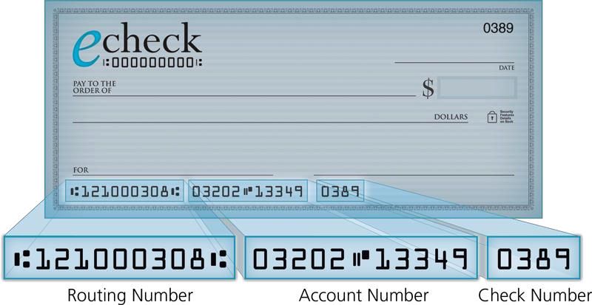

**NO PRESCRIPTION(S) CAN BE FILLED BEFORE AND DATED COPIES OF THIS ORDER FORM AND PATIENT APPLICATION HAVE BEEN ISSUED BY** [***EmedsMart.com***](https://www.emedsmart.com/)

# Patient authorization:

The foregoing terms and conditions regulate sales as between [***emedsmart.com***](https://www.emedsmart.com/) (the "Pharmacy") and the customer **(the "Patient"**) in respect of the goods and services **(the “Products”)** provided by the Pharmacy for sale.

1. I also completely and properly recorded my relevant details and health information and consent to the Pharmacy's usage of it. I have undergone a medical test from a specialist in the last 12 months, so will not need a physical exam.
2. I agree that a pharmacy located within a particular foreign jurisdiction and in a manner compliant with the laws of that jurisdiction shall market and dispense all Goods.
3. I approve and assign the pharmacy as my solicitor and representative to follow all action, sign all paperwork and work on my behalf as though I were present and working for the specific purposes of (a) receiving a legitimate prescription for every medication I have submitted to the pharmacy; and

(b) packing and distributing my medications to me. Such authorization shall involve, but not limited to: gathering and utilizing my identity and mental health records as fairly required for the execution of my request, including submission to a licensed practitioner if appropriate to obtain a legitimate prescription in the Pharmacy's jurisdiction. This authorization will at any point be withdrawn and will proceed until I revoke it.

1. I believe that the Pharmacy is lawfully established and fully allowed to do business. Within the Pharmacy's jurisdiction, and that I purchase medicines which have been approved

**For sale in Pharmacy jurisdiction.**

The description of my medicines moves from the Pharmacy to me in the Pharmacy authority as my medicines leave the Pharmacy. All deals or arrangements signed with the Pharmacy shall be considered to have been made under the Pharmacy's jurisdiction, sales shall be regulated by regulations of Pharmacy jurisdiction, and I attorn to the courts of the jurisdiction of the Pharmacy, that shall have sole and exclusive jurisdiction over any conflict between me and the Pharmacy, its affiliates, officers and directors.

I have read and accepted the terms and conditions set out in this Document and consent to be bound by certain terms and conditions on my own behalf by my successors, descendants, administrators and assigns.

I am the Patient's parent / legal guardian / procurator listed herein, am over the age of majority, and have absolute power to register on behalf of the patient and to make the following statements to the Pharmacy.

Patients Signature: Date (DD/MM/YY):

# For Queries – [info@emedsmart.com](mailto:info@emedsmart.com)

**Order Form Instructions**

Thank you for ordering with ***emedsmart.com***. We value your business.

To complete your order, simply follow above easy steps ensuring that all required fields are completed in full.

# Step 1 – Personal Contact Information

We use this information to create a customized account for you. All personal information remains confidential as we adhere to strict privacy standards and assure that personal information will not be distributed to any third parties other than for the purposes of completing and shipping your order.

# Step 2 – Order Details

Please ensure that you have indicated the medication, strength, quantity and price of the medication you are purchasing. As well, please indicate whether you have taken this medication before.

# Step 3 – Payment Information

Please choose a payment option. We accept Visa, MasterCard, check or you can choose to pay with bank transfer. Please send email at [[**info@emedsmart.com**](mailto:info@emedsmart.com)](mailto:admin@offshorecheapmeds.com%20) to request for bank details.

# Step 4 – Medical Information

This information is required to process any prescription (Rx) medication order. Rest assured, the information you provide is strictly confidential and is used solely by physicians and pharmacist for patient care purposes only. Customers ordering non-prescription (OTC) items only or returning customers who do not have updates to their health status can skip this step.

# Step 5 – Customer Agreement and submitting Order

Please review, sign and date the acknowledgement of the Customer Agreement. You may then submit your order form and any required documents by:

1. Toll Free : 1-801-708-0045
2. Email : [**info@emedsmart.com**](mailto:info@emedsmart.com)

We also offer convenient online ordering and our call center is open 6 days a week should you wish to place your order over the phone by calling toll-free 1-801-708-0045.

**Call Toll free :** 1-801-708-0045

**Email :** [**info@emedsmart.com**](mailto:info@emedsmart.com)